
Programming in Python CAP(776)
Report of Python Project
Olympic Data Analyzer

Submitted By:
Roll No. Name Registration No.
01 Vishal Alpuria 12325331
02 Rahul Kumar Gupta 12326327
06 Pranav Sharma 12324310

Submitted To:
Mr. Girish Kumar

ACKNOWLEGMENT

The development of the Olympic Data Analyzer project was an enriching experience, and I am grateful for the opportunity to undertake this project. I would like to extend my heartfelt thanks to those who supported and guided me throughout this journey.

First and foremost, I am deeply appreciative of my project advisor, Mr. Girish Kumar Sir for providing valuable insights and direction. Your guidance was instrumental in shaping the project and enhancing its functionality.

Vishal Alpuria 12325331
Rahul Kumar Gupta 12326327
Pranav Sharma 12324310

Table of content.

- Introduction
- Objectives
- System Functionality
- Given Menu
- Technology Stack
- Programming Language
- Data Structure
- IDE
- Libraries Used
- Data Source
- Key Features and Implementation
- Code
- Conclusion

Introduction
The Olympic Data Analyzer project aims to provide a comprehensive analysis of Olympic Games data from 2000 to 2024. This Python-based project offers an interactive menu system that allows users to explore various aspects of the data, including athlete counts, medal distribution, and other key statistics. The data is stored in a dictionary format, simulating a larger dataset, and the program is designed to facilitate user-driven exploration of Olympic history.

Objectives
The main objective of this project is to enable users to analyze Olympic data, focusing on key performance indicators such as the number of athletes, medals won, and their distribution across countries and sports. This analysis provides insight into the athletes' performance and country-wise contributions across different Olympic seasons, events, and categories

System Functionality
The system is designed to allow users to interact with a menu-driven interface that lets them query the dataset based on various criteria. It includes functions to computer like:-
- Total no of Athletes
- Number of Athletes per country
- Medal counts By country
- Average age of athletes by sport
- Distribution of medals by country, team, and session
- Average height and weight of athletes
- Year-wise medal distribution

Given Menu
The project offers a user-friendly interface with the following menu options:
Menu:
1. Total number of athletes
2. Number of athletes per country
3. Medal counts by country
4. Average age of athletes by sport
5. Distribution of medals
6. Medals won by each team
7. Medal counts by year
8. Average height and weight of athletes
9. Number of events by sport
10. Medal counts by season
11. Summary statistics for Height and Weight
12. Year Wise Distribution of Medals
0. Exit

Technology Stack
• Programming Language: Python
• Data Structure: Dictionary (used for storing Olympic data)
• IDE: Any Python IDE or terminal (e.g., Jupyter, VSCode)
• Libraries Used: No external libraries are required for basic
functionality. Python's standard libraries like input for user input, and data structures like lists and dictionaries are used for implementation.

Data Source
The data for this project is stored in a dictionary format. For example:
data_list = [{"ID": "2", "Name": "A Lamusi", "Sex": "M", "Age": "23", "Height": "170", "Weight": "60", "Team": "China", "NOC": "CHN", "Games": "2012 Summer", "Year": "2012", "Season": "Summer", "City": "London", "Sport": "Judo", "Event": "Judo Men's Extra-Lightweight", "Medal": "NA"}, {"ID": "9", "Name": "Antti Sami Aalto", "Sex": "M", "Age": "26", "Height": "186", "Weight": "96", "Team": "Finland", "NOC": "FIN", "Games": "2002 Winter", "Year": "2002", "Season": "Winter", "City": "Salt Lake City", "Sport": "Ice Hockey", "Event": "Ice Hockey Men's Ice Hockey", "Medal": "NA"}, {"ID": "12", "Name": "Jyri Tapani Aalto", "Sex": "M", "Age": "31", "Height": "172", "Weight": "70", "Team": "Finland", "NOC": "FIN", "Games": "2000 Summer", "Year": "2000", "Season": "Summer", "City": "Sydney", "Sport": "Badminton", "Event": "Badminton Men's Singles", "Medal": "NA"}, {"ID": "13", "Name": "Minna Maarit Aalto", "Sex": "F", "Age": "34", "Height": "159", "Weight": "55.5", "Team": "Finland", "NOC": "FIN", "Games": "2000 Summer", "Year": "2000", "Season": "Summer", "City": "Sydney", "Sport": "Sailing", "Event": "Sailing Women's Windsurfer", "Medal": "NA"}, {"ID": "16", "Name": "Juhamatti Tapio Aaltonen", "Sex": "M", "Age": "28", "Height": "184", "Weight": "85", "Team": "Finland", "NOC": "FIN", "Games": "2014 Winter", "Year": "2014", "Season": "Winter", "City": "Sochi", "Sport": "Ice Hockey", "Event": "Ice Hockey Men's Ice Hockey", "Medal": "Bronze"}, {"ID": "18", "Name": "Timo Antero Aaltonen", "Sex": "M", "Age": "31", "Height

In the real-world application, the dictionary would represent a larger dataset, possibly sourced from official Olympic datasets or CSV files. The dictionary holds the essential attributes of each athlete, including their ID, name, gender, age, height, weight, National Olympic Committee (NOC), sport, and medals wons
There is too much Data So show just an example of that Dict Data.
Key Features and Implementation:
- Total Number of Athletes: The system counts the total number of unique athletes by checking their unique IDs.
- Athletes Per Country: This feature computes the number of athletes representing each country, and allows the user to view either a specific country or a summary for all countries.
- Medals by Country: Users can retrieve the number of medals won by athletes from each country, categorized by gold, silver, and bronze.
- Average Age of Athletes by Sport: The system calculates the average age of athletes participating in different sports.
- Medal Distribution: Users can view the overall distribution of medals as well as the country with the highest count of gold, silver, and bronze medals.
- Medals Won by Team: This function tracks medals won by each team, broken down by medal type (gold, silver, bronze).
- Medals by Year: Users can see the number of medals awarded in each year for each type of medal.
- Average Height and Weight of Athletes: The program calculates the average height and weight of athletes, providing insight into the physical attributes of Olympic participants.
- Number of Events by Sport: This feature counts the total number of events for each sport in the dataset.
- Medal Counts by Season: Users can explore how medals are distributed across summer and winter Olympic games.
- Height and Weight Statistics: This function computes basic statistics (minimum, maximum, mean) for athletes' height and weight, giving an overview of the physical trends over the years.
- Year-wise Medal Distribution: The year-wise distribution of medals is displayed for each country, helping users analyze performance trends over time.

Code

# Olympic Data Analyzer from 2000 to 2016
def load_data():
#This list contains data from 2000 to 2016
data_list = [{"ID": "2", "Name": "A Lamusi", "Sex": "M", "Age": "23", "Height": "170", "Weight": "60", "Team": "China", "NOC": "CHN"]}
return data_list

def extract_nocs(data):
"""
National Olympic Committee (NOC)
"""
nocs = []
for entry in data:
nocs.append(entry['NOC'])
return nocs

def total_athletes(data):
# Total number of athletes
unique_athletes = set()
for row in data:
unique_athletes.add(row['ID'])
print(f"Total number of athletes: {len(unique_athletes)}")

def athletes_per_country(data):
# Function to count athletes per country
while True:
print("\nMenu: ")
print("1. Count all countries")
print("2. Count specific country")
print("0. Exit")

try:
choice = int(input("Enter your choice: "))
except ValueError:
print("Invalid input. Please enter a number.")
continue

if choice == 0:
break
elif choice == 1:
country_counts = {}
for row in data:
country = row['NOC']
if country in country_counts:
country_counts[country] += 1
else:
country_counts[country] = 1
print("Number of athletes per country:")
for country, count in country_counts.items():
print(f"{country}: {count}")
elif choice == 2:
country = input("Enter the country code: ").upper()
nocs = extract_nocs(data)
if country not in nocs:
print("Country not found.")
else:
country_count = sum(1 for row in data if row['NOC'] == country)
print(f"Number of athletes in {country}: {country_count}")
else:
print("Invalid choice. Please try again.")
def medals_by_country(data):
# Medal counts by country
while True:
print("\nMenu: ")
print("1. Count all countries")
print("2. Count specific country")
print("0. Exit")

choice = int(input("Enter your choice: "))

if choice == 0:
break
elif choice == 1:
medal_counts = {}
mc = {'Gold': 0, 'Silver': 0, 'Bronze': 0}

for row in data:
if row['Medal']:
country = row['NOC']
medal = row['Medal']
if country not in medal_counts:
medal_counts[country] = {}
if medal in medal_counts[country]:
medal_counts[country][medal] += 1
else:
medal_counts[country][medal] = 1
print("Medal counts by country:")
for country, medals in medal_counts.items():
mc = {'Gold': 0, 'Silver': 0, 'Bronze': 0}
print(f"{country}:",end="")
for key,value in medals.items():
if key == 'Bronze' or key == 'Silver' or key == 'Gold':
mc[key] += value
for key, val in mc.items():
print(f" {key:<5}: {val:<5}", end="")
print()
elif choice == 2:
mc = {'Gold': 0, 'Silver': 0, 'Bronze': 0}

country = input("Enter the country code: ").upper()
if country not in extract_nocs(data):
print("Country Not found")
else:
medal_counts = {}
for row in data:
if row['Medal'] and row['NOC'] == country:
medal = row['Medal']
if medal in medal_counts:
medal_counts[medal] += 1
else:
medal_counts[medal] = 1
print(f"Medal counts for {country}:",end="")
for key,val in medal_counts.items():
if key == 'Bronze' or key == 'Silver' or key == 'Gold':
mc[key] += val
for key,val in mc.items():
print(f" {key:<5}: {val:<5}", end="")
else:
print("Invalid choice. Please try again.")

def avg_age(data):
# Average age of athletes by sport
sport_ages = {}
for row in data:
age = row['Age']
if age.isdigit(): # Check if the age is a valid number
sport = row['Sport']
if sport not in sport_ages:
sport_ages[sport] = []
sport_ages[sport].append(float(age))

avg_age_by_sport = {}
for sport, ages in sport_ages.items():
avg_age_by_sport[sport] = sum(ages) / len(ages)

sorted_avg_ages = dict(sorted(avg_age_by_sport.items(), key=lambda item: item[1]))
print("Average age of athletes by sport:")
for sport, avg_age in sorted_avg_ages.items():
print(f"{sport}: {avg_age:.2f}")

def distribution_med(data):
# Distribution of medals
medal_distribution = {}
for row in data:
if row['Medal']:
medal = row['Medal']
if medal in medal_distribution:
medal_distribution[medal] += 1
else:
medal_distribution[medal] = 1
print("Distribution of medals:")
for medal, count in medal_distribution.items():
if(medal != 'NA'):
print(f"{medal}: {count}")

# Country with highest gold, silver, and bronze medals
gold_count = 0
silver_count = 0
bronze_count = 0
gold_country = ""
silver_country = ""
bronze_country = ""
for row in data:
if row['Medal'] == 'Gold':
gold_count += 1
gold_country = row['NOC']
elif row['Medal'] == 'Silver':
silver_count += 1
silver_country = row['NOC']
elif row['Medal'] == 'Bronze':
bronze_count += 1
bronze_country = row['NOC']

print(f"Country with highest gold medals: {gold_country} ({gold_count} gold medals)")
print(f"Country with highest silver medals: {silver_country} ({silver_count} silver medals)")
print(f"Country with highest bronze medals: {bronze_country} ({bronze_count} bronze medals)")

def medals_won_team(data):
# Medals won by each team
team_medals = {}
for row in data:
medal = row['Medal']
if medal and medal != 'NA': # Skip 'NA' medals
team = row['Team']
if team not in team_medals:
team_medals[team] = {'Gold': 0, 'Silver': 0, 'Bronze': 0}
if medal in team_medals[team]:
team_medals[team][medal] += 1

print("Medals won by each team:")
print(f"{'Team':<50} {'Gold':<5} {'Silver':<6} {'Bronze':<6}")
print("-" * 80)

for team, medals in team_medals.items():
print(f"{team:<50} {medals['Gold']:<5} {medals['Silver']:<6} {medals['Bronze']:<6}")

def medals_by_year(data):
# Medal counts by year
medal_counts_by_year = {}
for row in data:
medal = row['Medal']
if medal and medal != 'NA': # Skip 'NA' medals
year = row['Year']
if year not in medal_counts_by_year:
medal_counts_by_year[year] = {'Gold': 0, 'Silver': 0, 'Bronze': 0}
if medal in medal_counts_by_year[year]:
medal_counts_by_year[year][medal] += 1

# Print the formatted output
print("Medal counts by year:")
print(f"{'Year':<10} {'Gold':<5} {'Silver':<6} {'Bronze':<6}")
print("-" * 30)

for year, medals in sorted(medal_counts_by_year.items()):
print(f"{year:<10} {medals['Gold']:<5} {medals['Silver']:<6} {medals['Bronze']:<6}")

def avg_height(data):
# Initialize variables to compute average height
total_height = 0.0
count = 0

for row in data:
height = row['Height']
if height and height != 'NA': # Skip 'NA' and empty values
try:
total_height += float(height)
count += 1
except ValueError:
# Handle cases where conversion fails
print(f"Warning: Skipping invalid height value: {height}")

if count > 0:
average_height = total_height / count
else:
average_height = 0.0

print(f"Average height of athletes: {average_height:.2f} cm")

def no_events(data):
# Number of events by sport
event_counts_by_sport = {}
for row in data:
sport = row['Sport']
if sport in event_counts_by_sport:
event_counts_by_sport[sport] += 1
else:
event_counts_by_sport[sport] = 1

# Print the formatted output
print("Number of events by sport:")
print(f"{'Sport':<30} {'Number of Events':<15}")
print("-" * 50)

for sport, count in sorted(event_counts_by_sport.items()):
print(f"{sport:<30} {count:<15}")

def medals_by_season(data):
# Medal counts by season
medal_counts_by_season = {}
for row in data:
if row['Medal'] and row['Medal'] != 'NA': # Skip 'NA' medals
season = row['Season']
medal = row['Medal']
if season not in medal_counts_by_season:
medal_counts_by_season[season] = {'Gold': 0, 'Silver': 0, 'Bronze': 0}
if medal in medal_counts_by_season[season]:
medal_counts_by_season[season][medal] += 1

# Print the formatted output
print("Medal counts by season:")
print(f"{'Season':<10} {'Gold':<5} {'Silver':<6} {'Bronze':<6}")
print("-" * 30)

for season, medals in sorted(medal_counts_by_season.items()):
print(f"{season:<10} {medals['Gold']:<5} {medals['Silver']:<6} {medals['Bronze']:<6}")

def stats_height_weight(data):
# Lists to hold heights and weights
heights = []
weights = []

for row in data:
height = row.get('Height')
weight = row.get('Weight')

# Check if height and weight are valid and not 'NA'
if height and height != 'NA':
try:
heights.append(float(height))
except ValueError:
print(f"Warning: Skipping invalid height value: {height}")

if weight and weight != 'NA':
try:
weights.append(float(weight))
except ValueError:
print(f"Warning: Skipping invalid weight value: {weight}")

if heights and weights:
# Calculate statistics
height_min = min(heights)
height_max = max(heights)
height_mean = sum(heights) / len(heights)

weight_min = min(weights)
weight_max = max(weights)
weight_mean = sum(weights) / len(weights)

# Print summary statistics
print("Summary statistics for Height and Weight (in cm):")
print(f"Height - Min: {height_min:.2f} cm, Max: {height_max:.2f} cm, Mean: {height_mean:.2f} cm")
print(f"Weight - Min: {weight_min:.2f} kg, Max: {weight_max:.2f} kg, Mean: {weight_mean:.2f} kg")
else:
print("No valid height and weight data available.")

def year_wise_medal_distribution(data):
country = input("Enter the country code: ").upper()

if country not in extract_nocs(data):
print("Country Not found")
return

year_wise_distribution = {}
for row in data:
if row['Medal'] and row['Medal'] != 'NA' and row['NOC'] == country:
year = row['Year']
medal = row['Medal']
if year not in year_wise_distribution:
year_wise_distribution[year] = {'Gold': 0, 'Silver': 0, 'Bronze': 0}
if medal in year_wise_distribution[year]:
year_wise_distribution[year][medal] += 1

print(f"Year Wise Medal Distribution for {country}:")
print(f"{'Year':<10} {'Gold':<5} {'Silver':<6} {'Bronze':<6}")
print("-" * 30)
for year, medals in sorted(year_wise_distribution.items()):
print(f"{year:<10} {medals['Gold']:<5} {medals['Silver']:<6} {medals['Bronze']:<6}")

def menu():
data = load_data()
while True:
print("\nMenu:")
print("1. Total number of athletes")
print("2. Number of athletes per country")
print("3. Medal counts by country")
print("4. Average age of athletes by sport")
print("5. Distribution of medals")
print("6. Medals won by each team")
print("7. Medal counts by year")
print("8. Average height and weight of athletes")
print("9. Number of events by sport")
print("10. Medal counts by season")
print("11. Summary statistics for Height and Weight")
print("12. Year Wise Distribution of Medals")
print("0. Exit")

choice = int(input("Enter your choice: "))

if choice == 0:
break
elif choice == 1:
total_athletes(data)
elif choice == 2:
athletes_per_country(data)
elif choice == 3:
medals_by_country(data)
elif choice == 4:
avg_age(data)
elif choice == 5:
distribution_med(data)
elif choice == 6:
medals_won_team(data)
elif choice == 7:
medals_by_year(data)
elif choice == 8:
avg_height(data)
elif choice == 9:
no_events(data)
elif choice == 10:
medals_by_season(data)
elif choice == 11:
stats_height_weight(data)
elif choice == 12:
year_wise_medal_distribution(data)
else:
print("Invalid choice. Please try again.")

if __name__ == "__main__":
menu()

OUTPUT

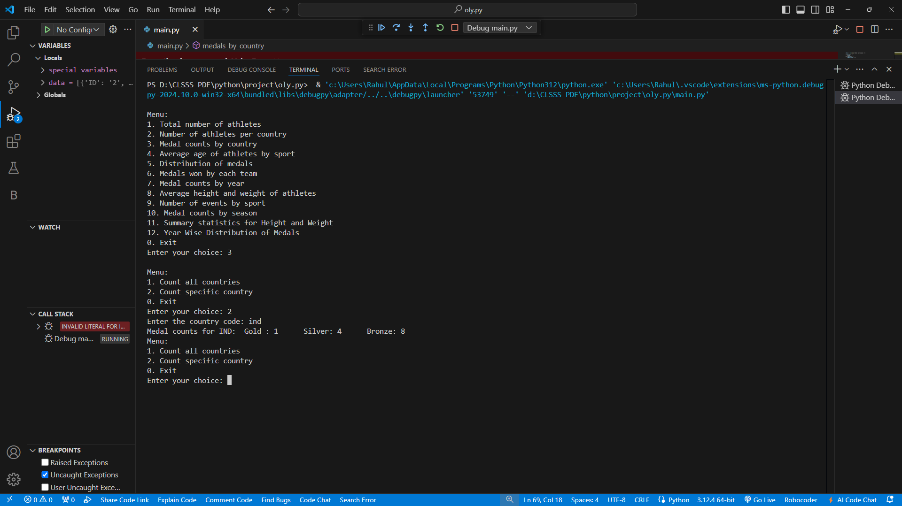
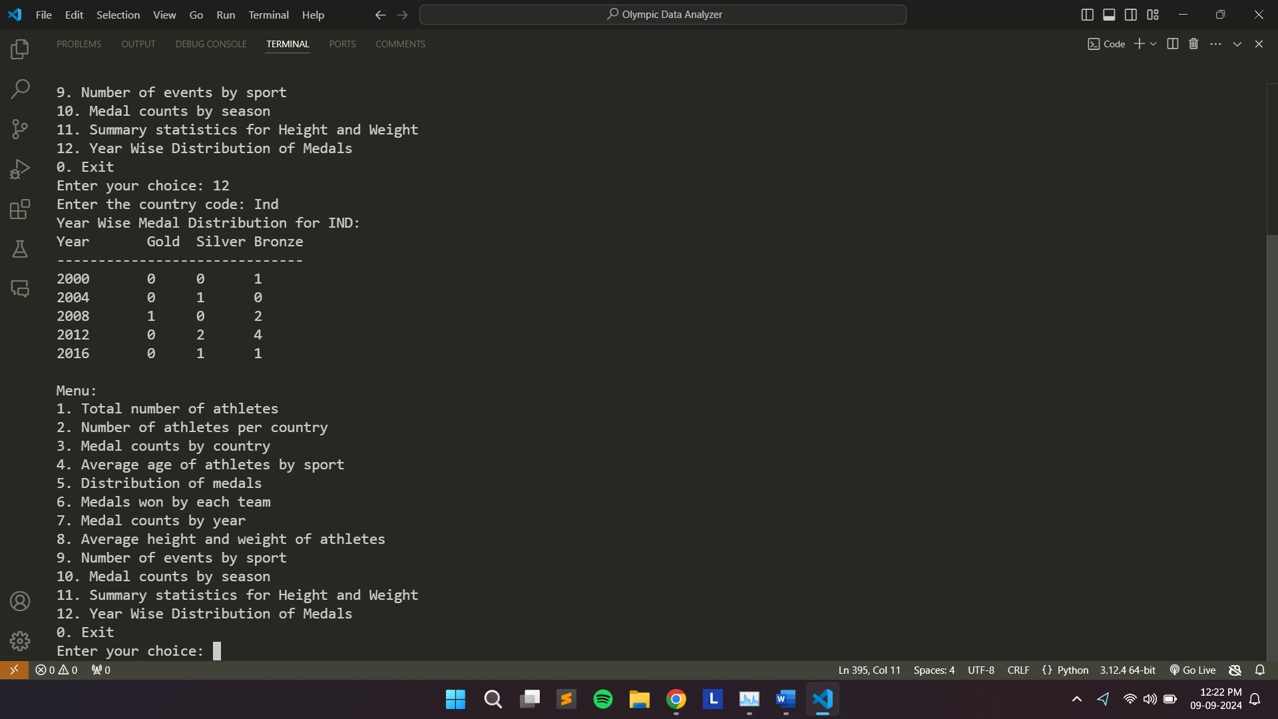
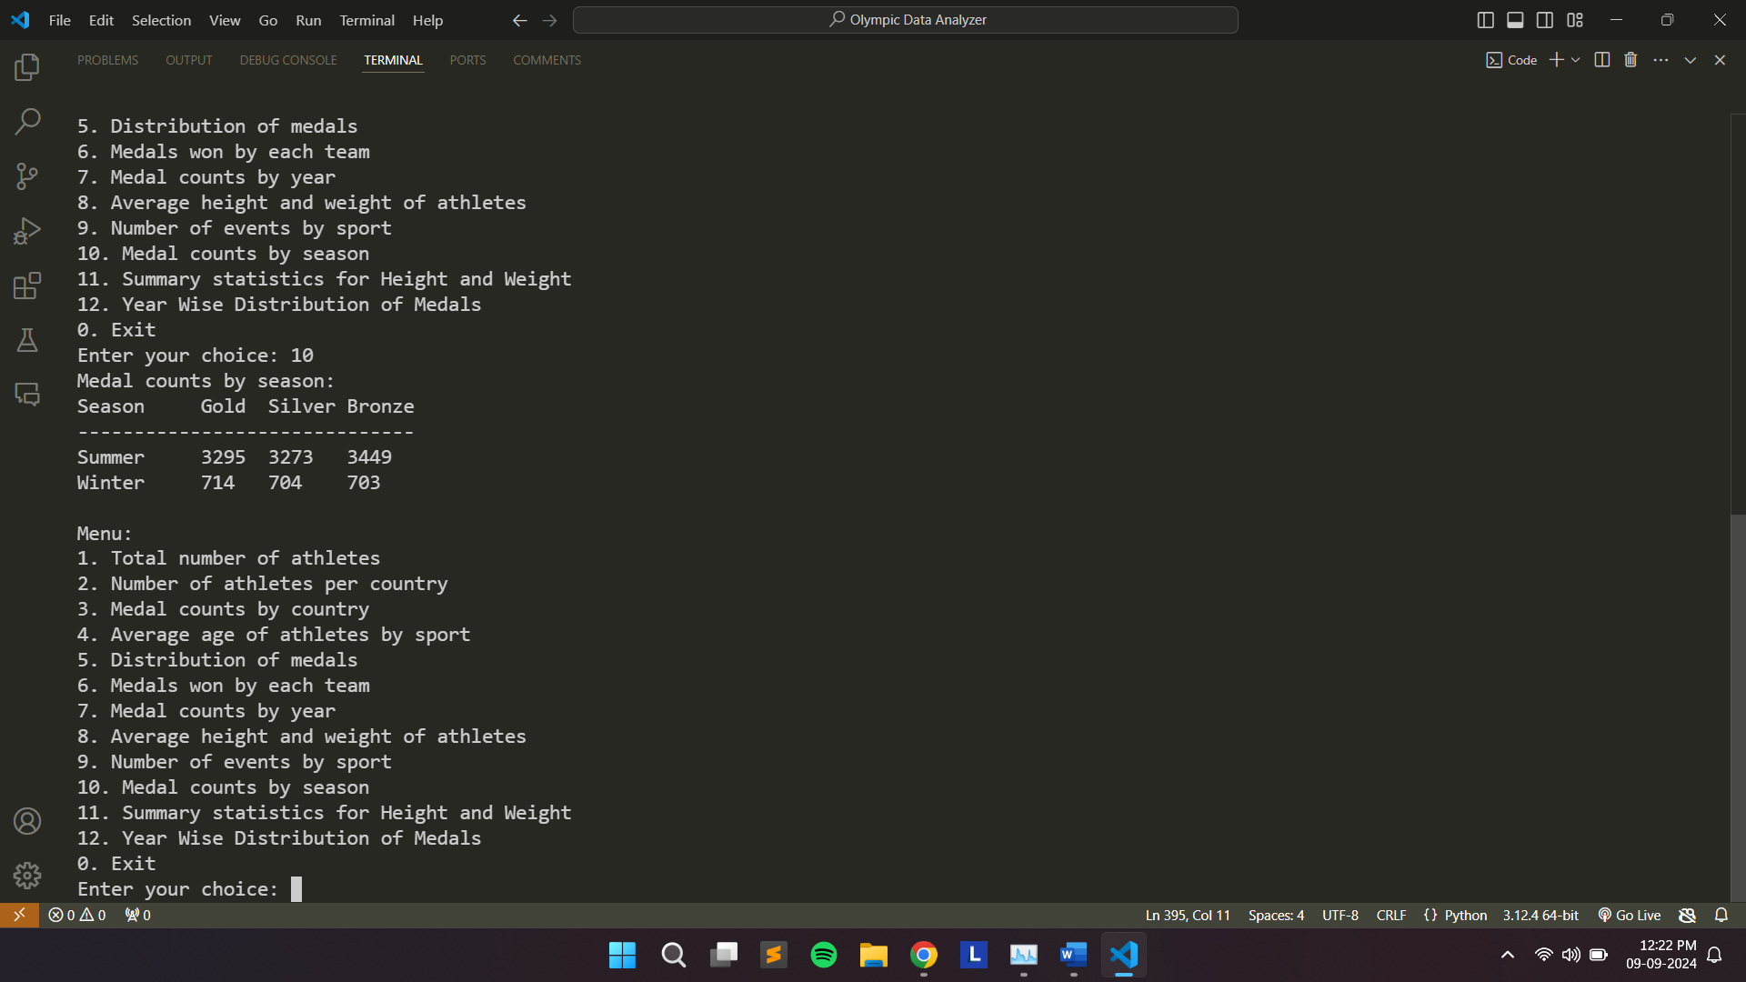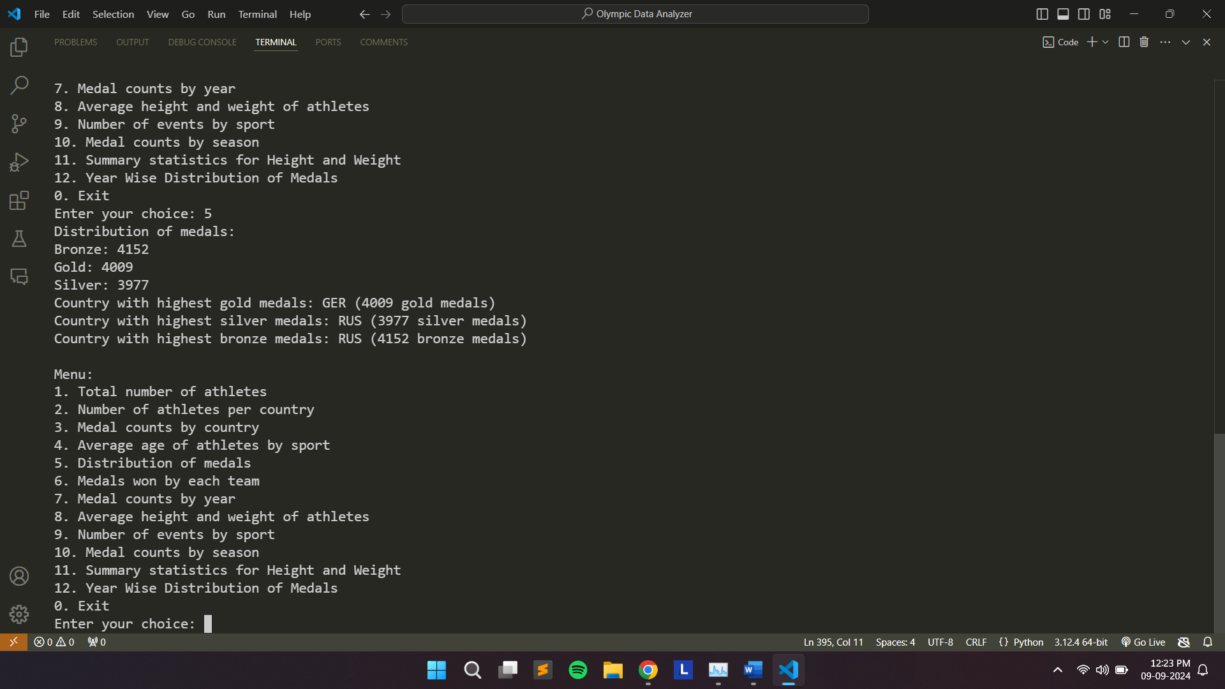

Conclusion:
The Olympic Data Analyzer project provides a powerful tool for analysing Olympic data. With a simple yet effective menu system, it allows users to extract meaningful insights from the dataset. By implementing various features like athlete counts, medal distributions, and physical statistics, the project gives a comprehensive view of the Olympic Games between 2000 and 2024. With further expansion and the inclusion of real datasets, this project could be a valuable resource for sports analysts and enthusiasts alike.

